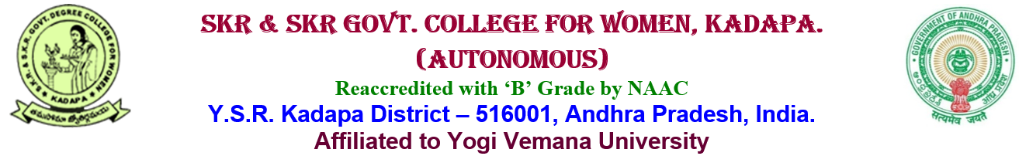__________________________________________________________________________
5.1.4: Average percentage of students benefited by career counseling and guidance for competitive examinations as offered by the Institution during the last five years.
Career Guidance Cell
The Career Guidance and Placement Cell is a resource for seeking career related information that helps the students take advantage of new or upcoming job opportunities. The Cell provides students with the resources and skills necessary to pursue their career goals. The Cell is mainly responsible for establishing contact with various organizations and arranging interviews for the students. The Cell functions under the guidance of Placement Officers.
Career Guidance Cell functions in this institution with the objectives of to provide learning/training opportunities in the areas of academic, career and personal/ Social development and to prepare students to meet their future challenges. Supporting the students in identifying their interests, strengths and planning appropriately to justify their professional needs.
Objectives:

- To develop recruitment strategies that will attract professional supporters in leading institutions for the purpose of building a coalition of professional support.
- The purpose of this cell is counselling students and providing employment-readiness services that will meet the demands of a highly skilled workforce, thus creating interest and professionalism in the students
The various career guidance activities proposed to be undertaken are:

  - To motivate students to take the plunge into entrepreneurship, training classes are organized. Budding entrepreneurs are given guidance to further their career and start off on their own.
  - Career counselling programs are undertaken by the placement coordinator to guide the students when ever required. Interactive sessions by the leaders in respective fields are conducted regularly. This keeps the students in touch with the latest developments in their field of choice, thereby bringing them at par with the best brains of the country.
  - Various talks, symposiums and workshops by eminent personalities are conducted on a regular basis which exposes the students to various career opportunities.
  - Personality development programs, mock interviews and mock GD sessions are conducted to enhance the communication skills of the students and to make them proficient in appearing for the same

Activities of the Career Guidance and Placement Cell
  - Knowledge building sessions
  - Training in basic communication skills
  - Training in group discussion and interview skills
  - Aptitude Test training
  - Excel training
- Career Guidance sessions from industry experts helping students to make informed choices regarding their careers.
- Campus recruitment by leading companies offering challenging job profiles.

CAREER GUIDANCE AND PLACEMENT CELL
Coaching For Minorities Students
Dt: 04-04-2022

Career guidance and Placement Cell of SKR & SKR GDC for Women(A)Kadapa actively conducted and co-ordinate various computer courses for women in the neighbouring locality and for college students. Various courses like C, Tally, PGDCA, Ms-Office, DCA, Employability skills, are being offered. These activities are being conducted to equip women for employment. The course structure include theoretical sessions along with practical sessions.

A session on skill enhancement and career development was conducted for the final year Degree students by the “K12AA INVENT “AP Minorities cell, Kadapa and Future Tech Institute, KadapaFrom 04.04.2022 to 30.5.2022.

Coordinator
Dr.Shazeeya Begum
Incharge, Dept. of Urdu

K12AA INVENT From 04.04.2022 to 30.5.2022
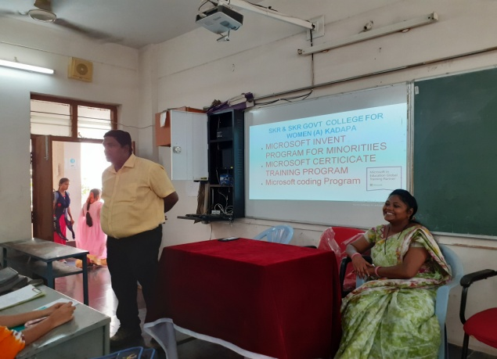

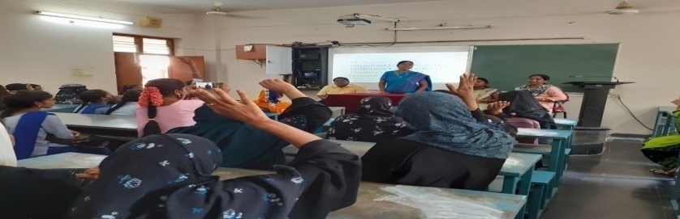
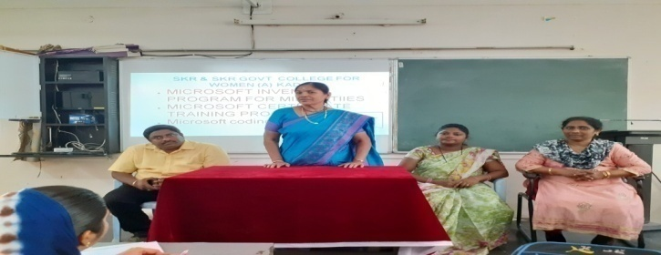

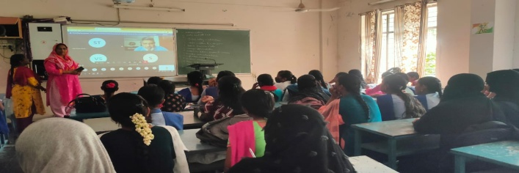
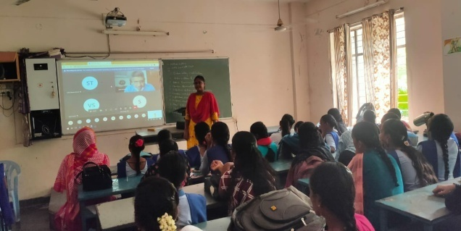

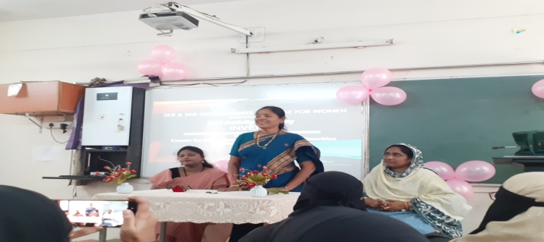

CAREER GUIDANCE AND PLACEMENT CELL
Coaching For Minorities Students
Dt: 21-12-2021

A session on “Civil Services awareness and how to clear Civil Services Examinations easily” was conducted by Hazarath Ayesha Career Academy, Kadapa & MIS Civil Service Academy, Hyderabad on 21st December2021. Shaik Tasleem Ara & Shaik Jeelan Basha handled motivational sessions for the students. Seminar on “Civil Services awareness and how to clear Civil Services Examinations easily” was taken by Shaik Tasleem Ara. Along with our college students, the programme was attended by students from different areas of the district. About 90 participants were benefitted.

Coordinator
Dr.Shazeeya Begum
Incharge, Dept. of Urdu

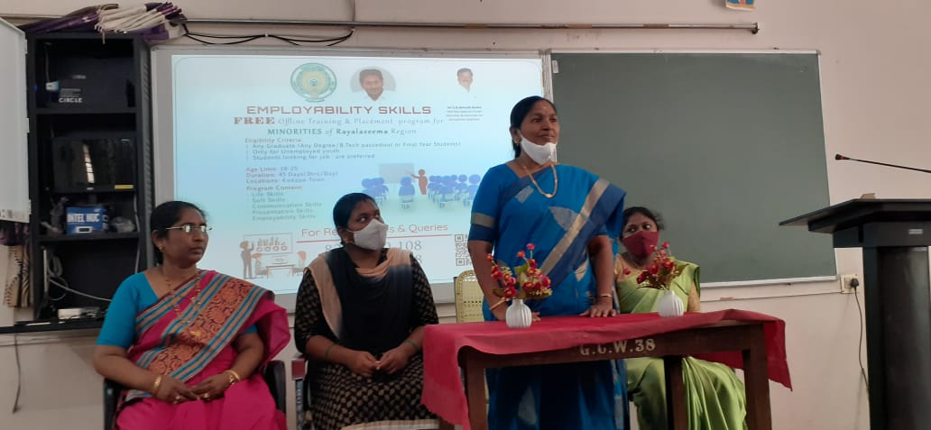

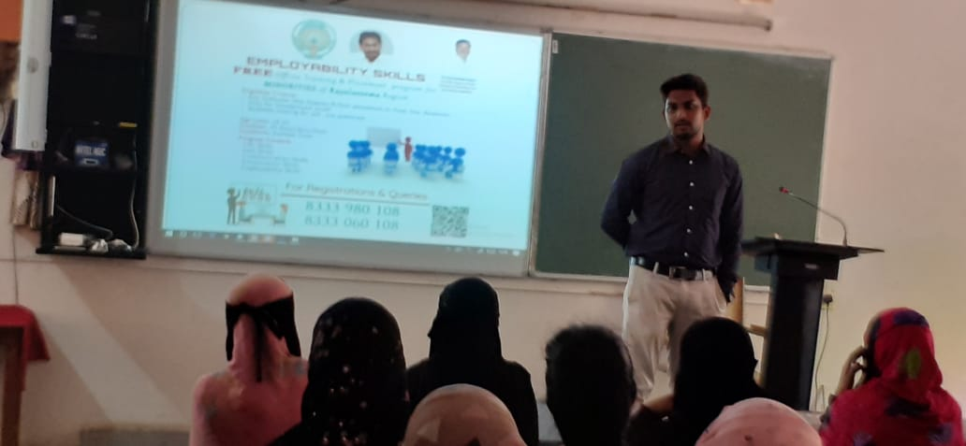
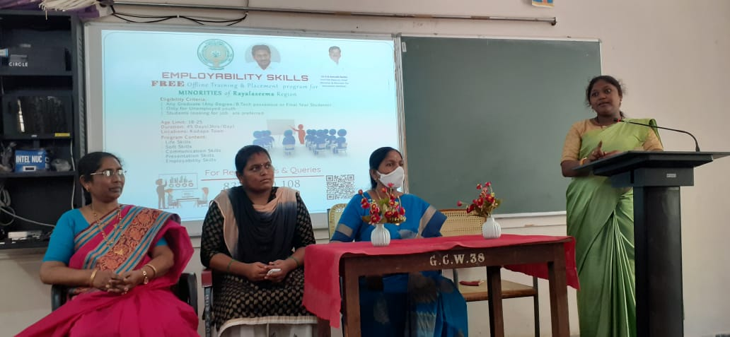

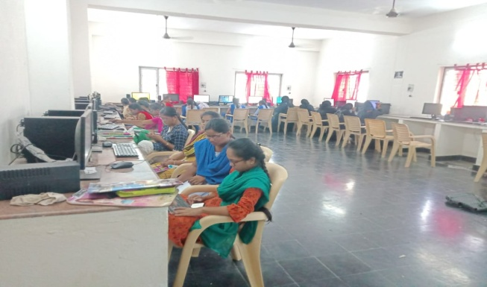

CAREER GUIDANCE AND PLACEMENT CELL
Coaching For Minorities Students
Dt: 20-12-2021

A session on career advancements and a motivational session was conducted for the students on 20 December, 2021. The session was handled by Senior LIC Officer & Correspondent of Hazrat Ayesha Group of Institution Shaik Jeelan Basha has 22 years of service. The session intended to give students an awareness on various Professional courses like CA, CS, ICWA etc.
Thesession also focused mainly on the need for “Developing Effective Language and Communication Skills” by Shaik Ghouse Moinuddin, Rtd. Senior Asst. About 80 students benefitted from the programme.

Coordinator
Dr.Shazeeya Begum
Incharge, Dept. of Urdu

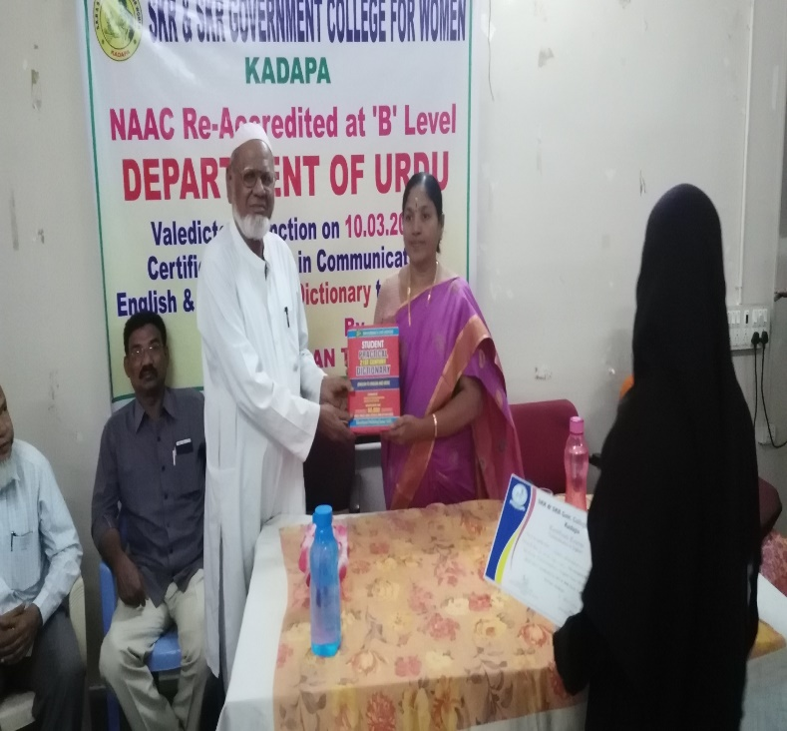

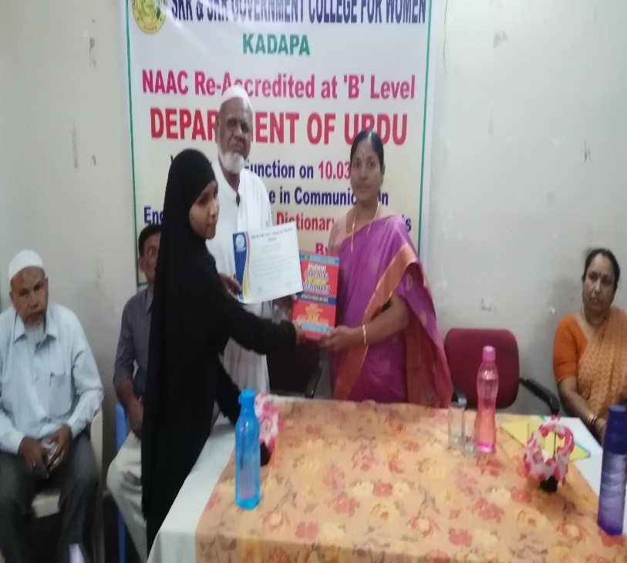

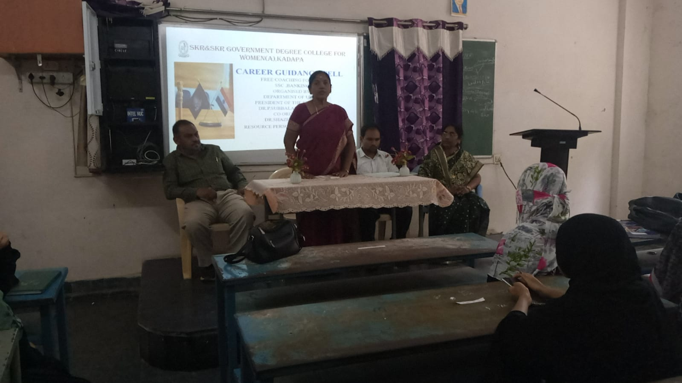

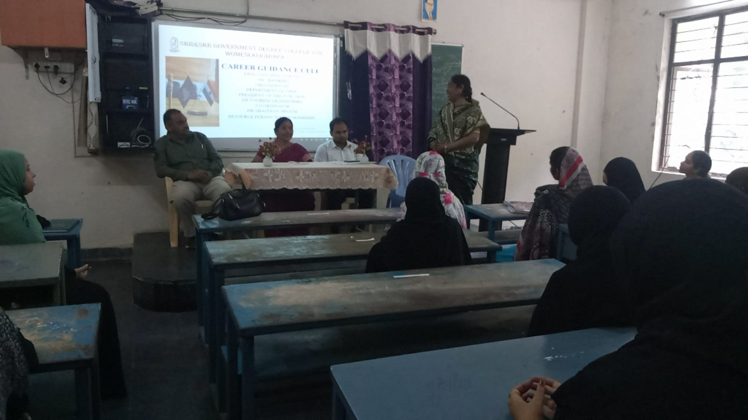

Coaching For Competitive Examinations on Analytical and English Skills :

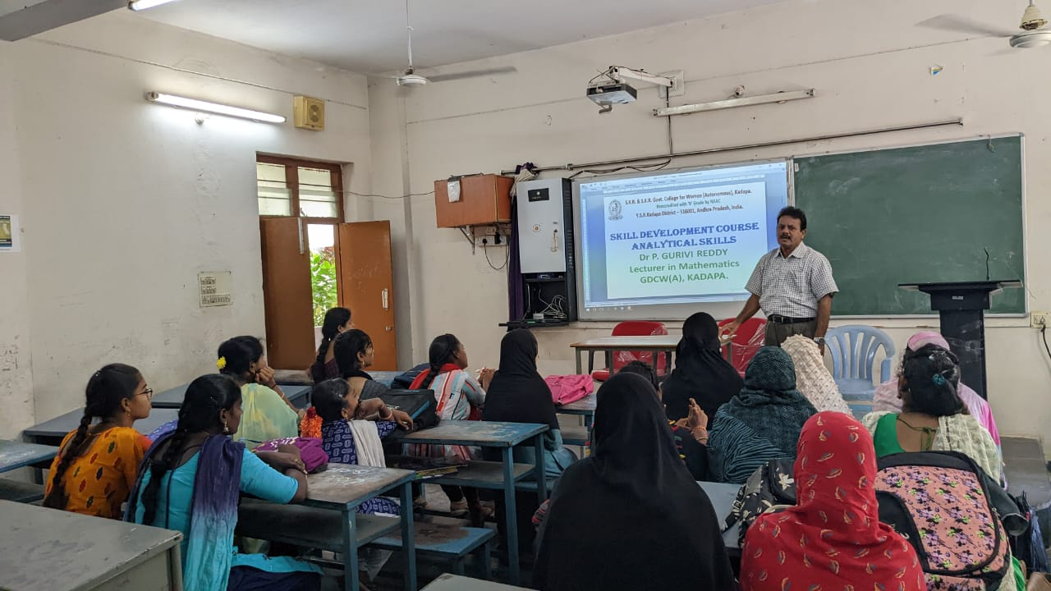

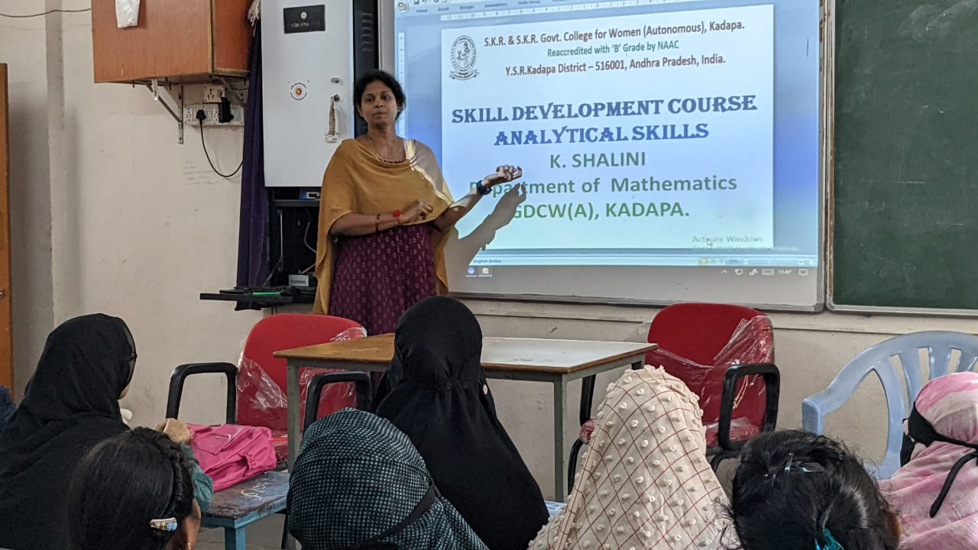

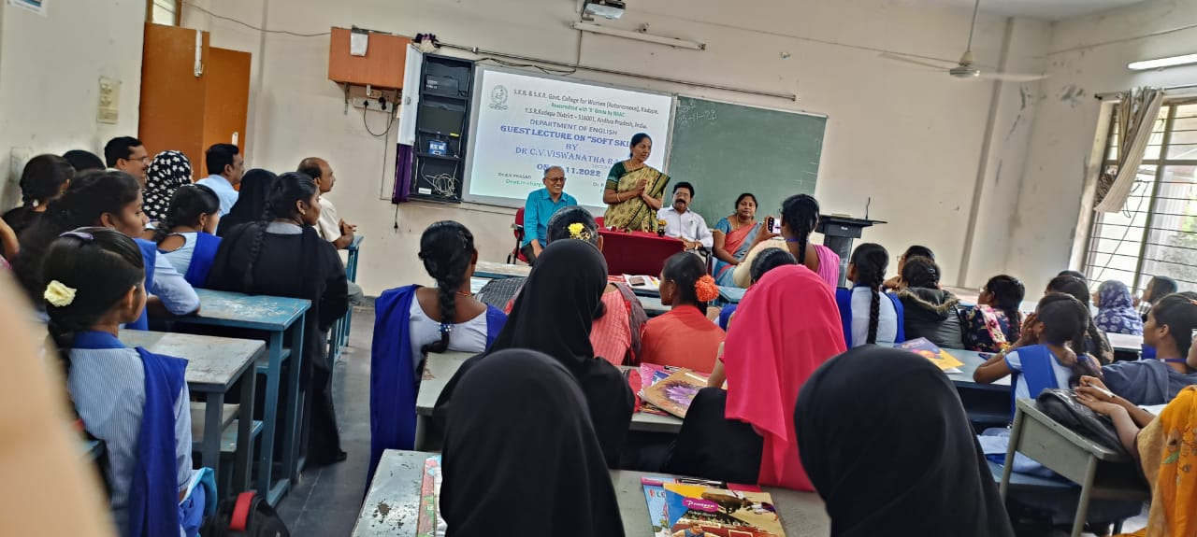

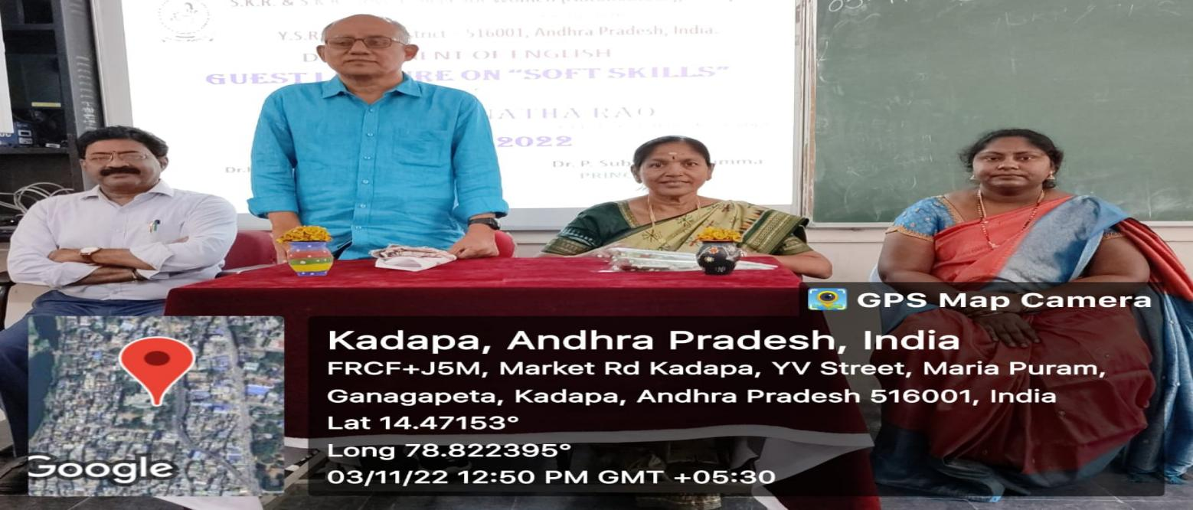

CAREER GUIDANCE AND PLACEMENT CELL
Career Guidance Coaching ForJob Opportunities
Dt: 16-09-2021

Department of Economics organised Career Guidance and motivation class to BA students on 16.09.2021. Dr P.SubbaLakshumma inaugurated the Meeting and explained the opportunities after graduation. Sri B.Subramanyam acted as Resource person and explained the job opportunities after graduation with PowerPoint presentation.

Coordinator
Dr.Shazeeya Begum
Incharge, Dept. of Urdu

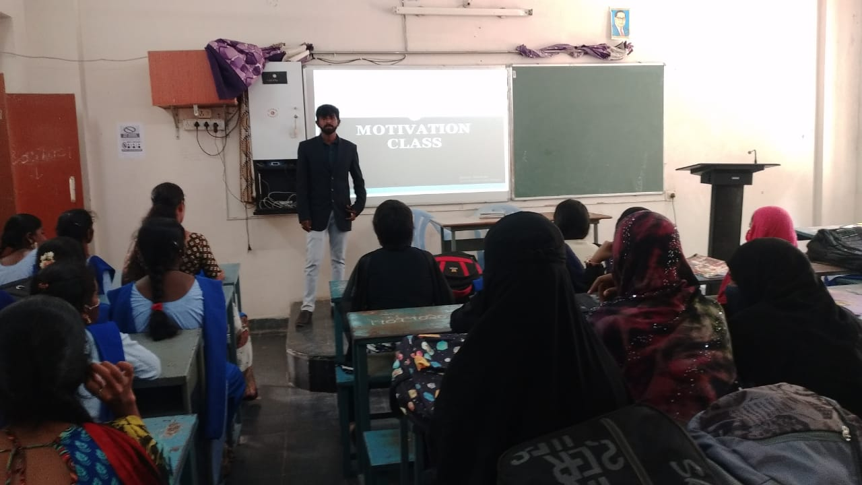

CAREER GUIDANCE AND PLACEMENT CELL
Career Guidance and Job Opportunities
Dt: 02-08-2021

The College Career Guidance Cell organized a programme on 02-08-2021 entitled “CAREER GUIDANCE & JOB OPPORTUNITIES” to interact with the professionals and experts from various Institutions and sources to educate and to set goals and objectives in right direction to achieve desired targets. Dr. P. SubbaLakshumma, Principal of this institution explained the need of higher education for women to reap better opportunities and for empowerment of women. She also said that those who improve the potentiality and capability will get better opportunities in this competitive world.
Sri. M.C. Raveendra, director of SPIRTS P.G, MBA and MCA college gave message to the students to contribute their education further to get better opportunities in this global world. Power Point presentation given by Sri. Ravi Sankar, Vice-Principal of spirts college on APICET-2021. Sri. O.KhajaMohideen, Convener & Smt. Shazeeya Begum Co-Convener of this programme said that programme will help the students to decide their career for better future.

Coordinator
O.KhajaMohideen
Dept. Of Commerce
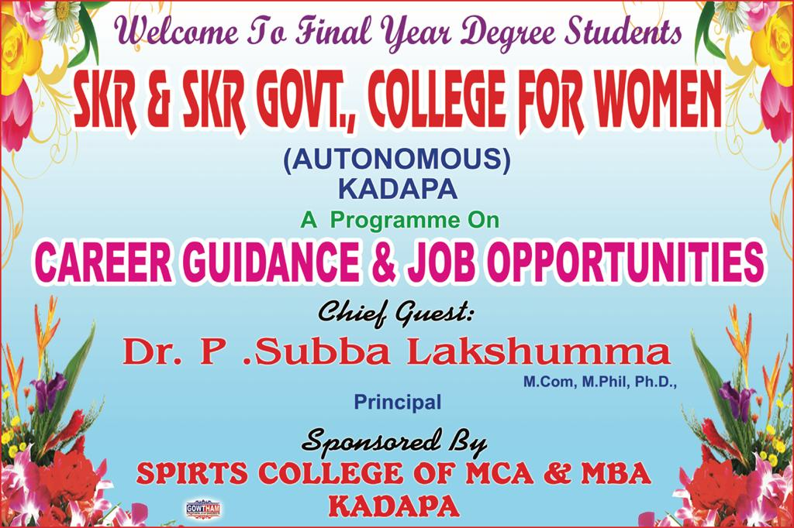

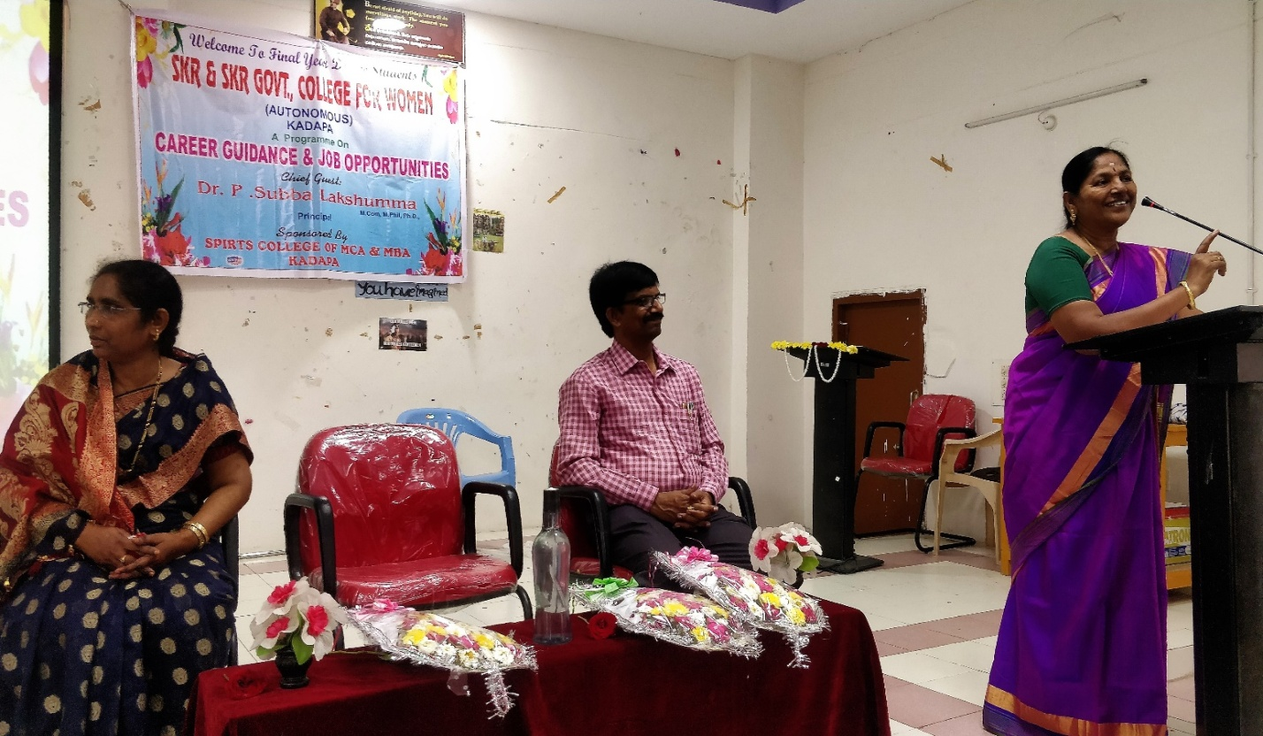

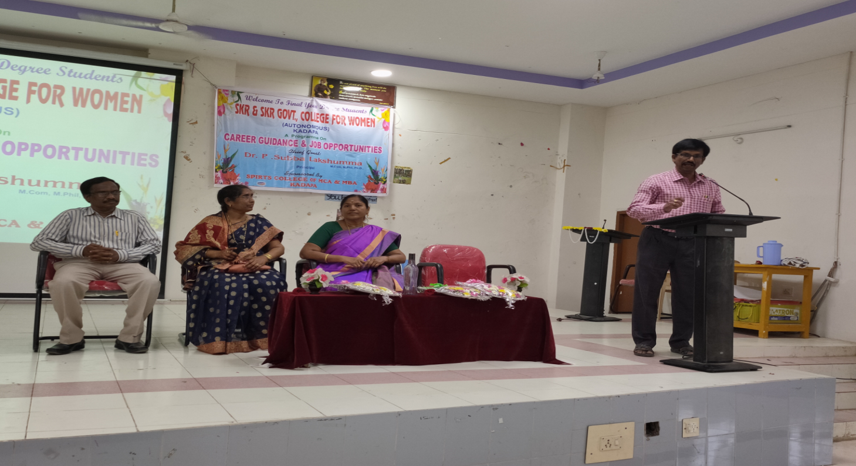

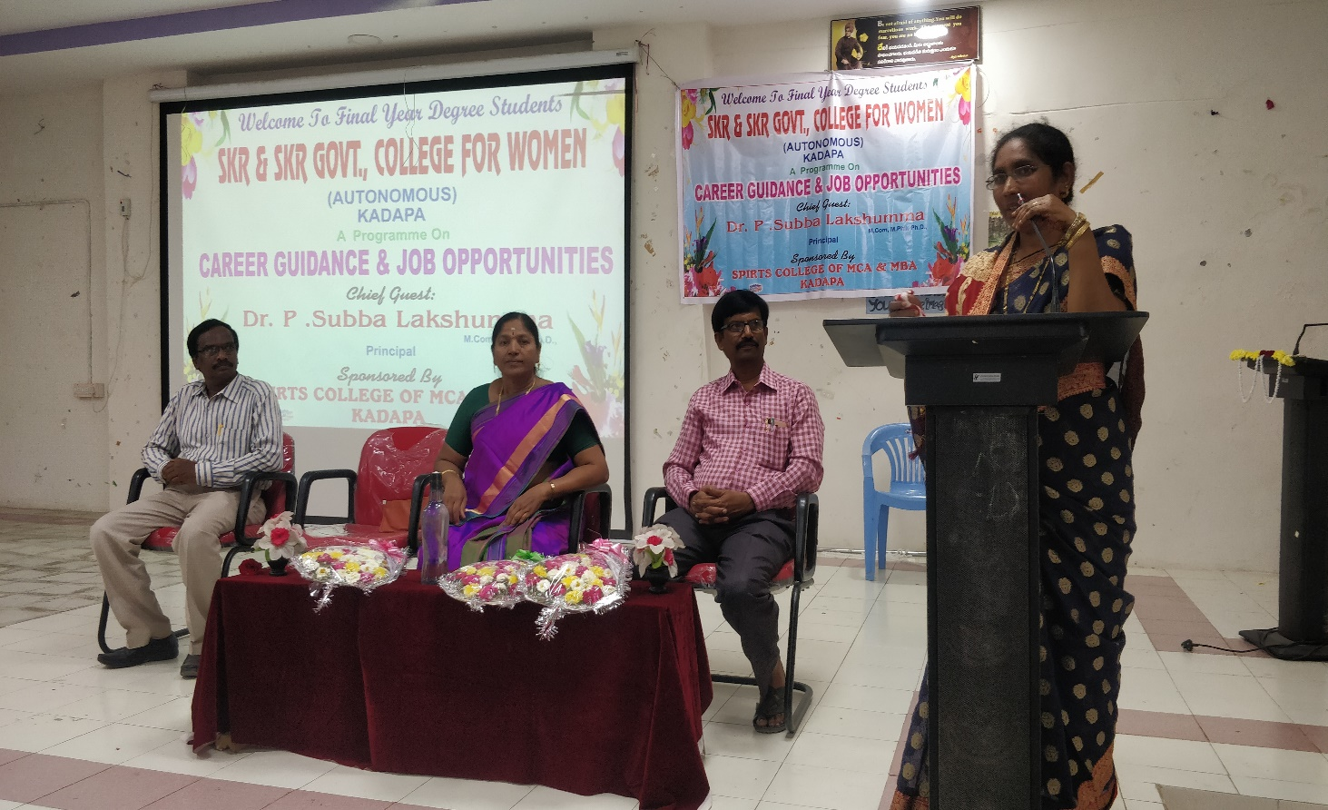

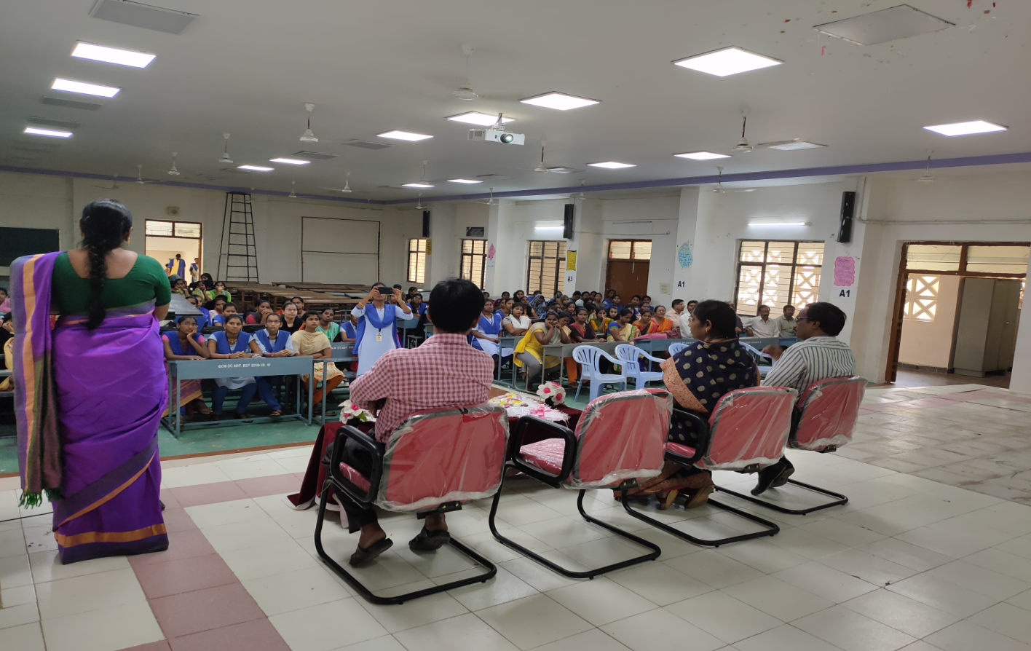

CAREER GUIDANCE AND PLACEMENT CELL
Employability Skills and Job Opportunities
Dt: 22-04-2021

The Career Guidance Cell organized a programme on 22-04-2021 entitled “Employability Skills and Job Opportunities” by inviting Resource person Prof. P. Prasanna Kumari, Department of Digital Techniques, Dr.YSRAFU, Kadapa.She educated the students on various Computer based skills like Preparation of CV, Applying for Job, Facing interview and various Job skills.
Dr. P. SubbaLakshumma, Principal of this institution explained the need of higher education for women to get better opportunities and for empowerment of women. She also said that those who improve the potentiality and capability will get better opportunities in this competitive world.Smt. A.Haritha, Convener organised this programme for students benefit.

Coordinator
      - Haritha
Incharge, Dept. of Computer Science
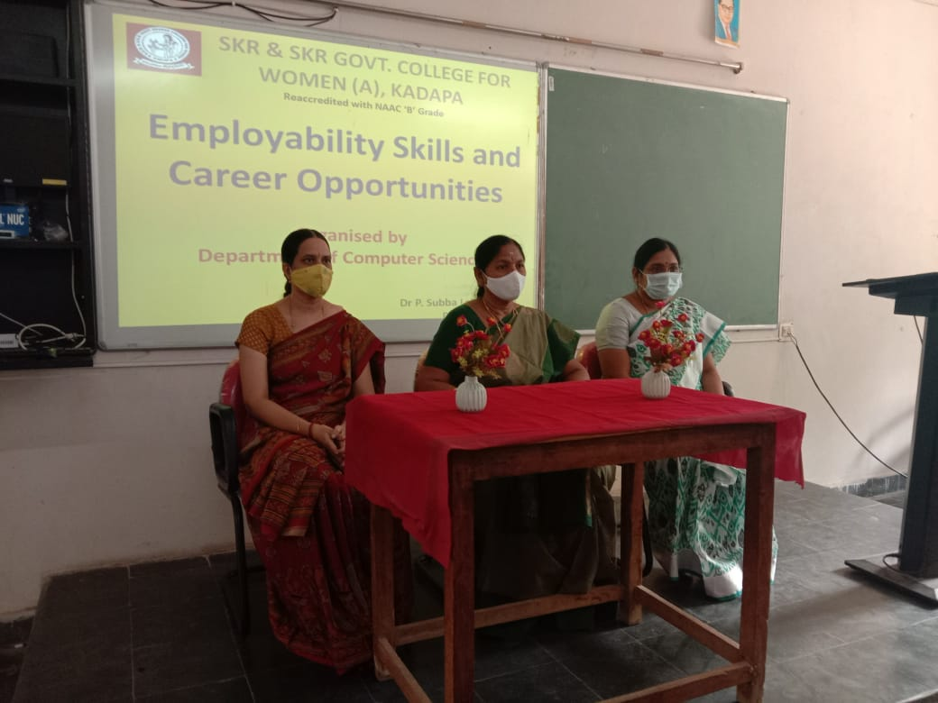

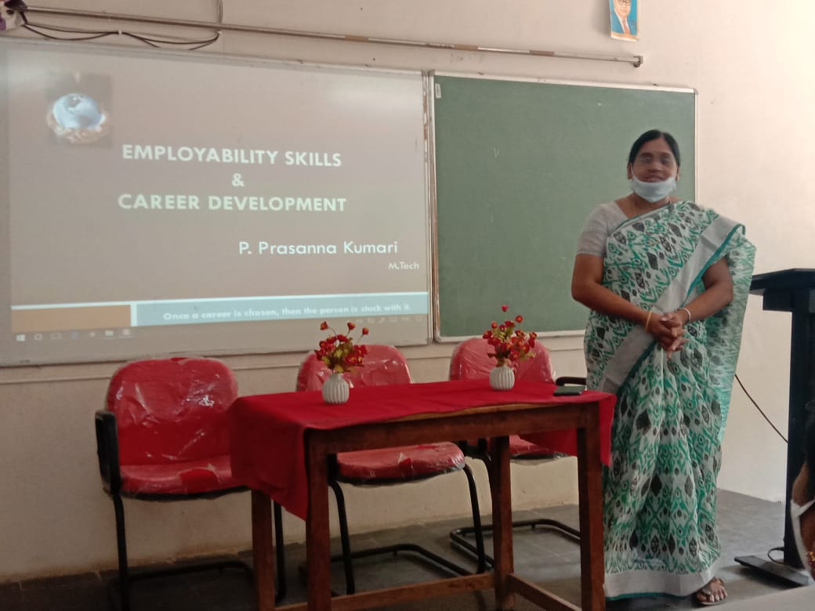

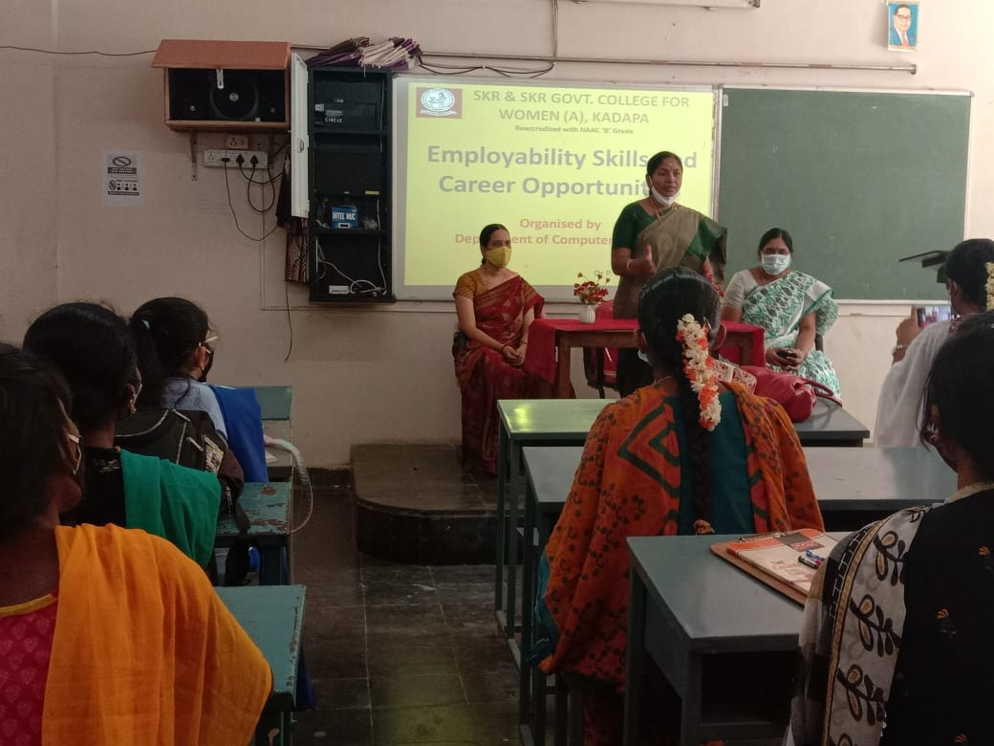

CAREER GUIDANCE AND PLACEMENT CELL
Career Guidance and Job Opportunities
Dt: 05-03-2020

The College Career Guidance Cell organized a programme on 05-03-2020 entitled “CAREER GUIDANCE & JOB OPPORTUNITIES” with Resource Person Sri. M.C. Raveendra, Director of SPIRTS College gave message to the students to contribute their education further to get better opportunities in this global world. Sri. O.KhajaMohideen, Coordinator of this programme said that programme will help the students to decide their career for better future.

Coordinator
O.KhajaMohideen
Dept. Of Commerce

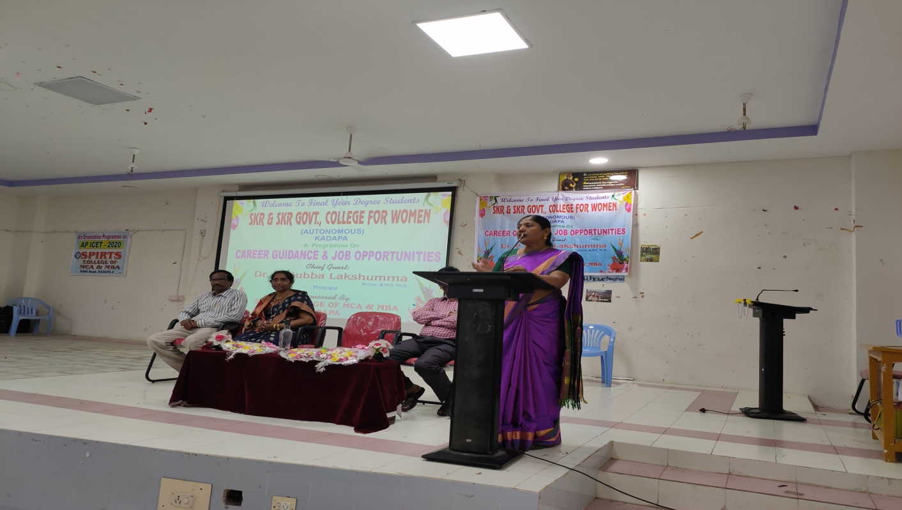

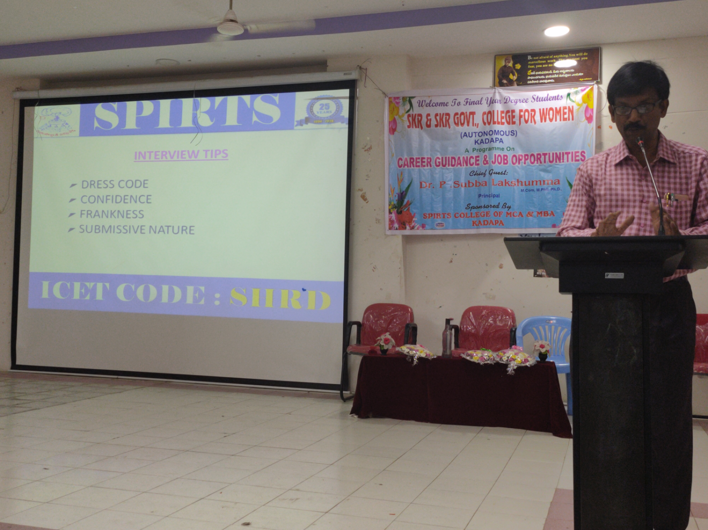

CAREER GUIDANCE AND PLACEMENT CELL
Career Guidance and Job Opportunities
Dt: 17-02-2020

“Career Guidance & Job opportunities” Programme was organized on 17-2-2020 by CAREER GUIDANCE CELL with the encouragement of Dr.P.Subbalakshumma, principal of S.K.R. & S.K.R Govt. College for Women, (A) Kadapa and this Programme was sponsored by Bharath Engineering College for Women, Kadapa for especially for Final year B.Com, B.A, and B.Sc. students. Smt. L.Sudheera, Vice-principal of this College explained the importance of career coaching and right guidance before they are going to choose an academic stream.
The resource person Mr. Vijay Kumar garuexpert in Personality Development training VIMP spread out the career options in the public sectors and job opportunities. During the programme he conducted memory test for students and distributed money prizes respectively.

Coordinator
O.KhajaMohideen
Dept. Of Commerce

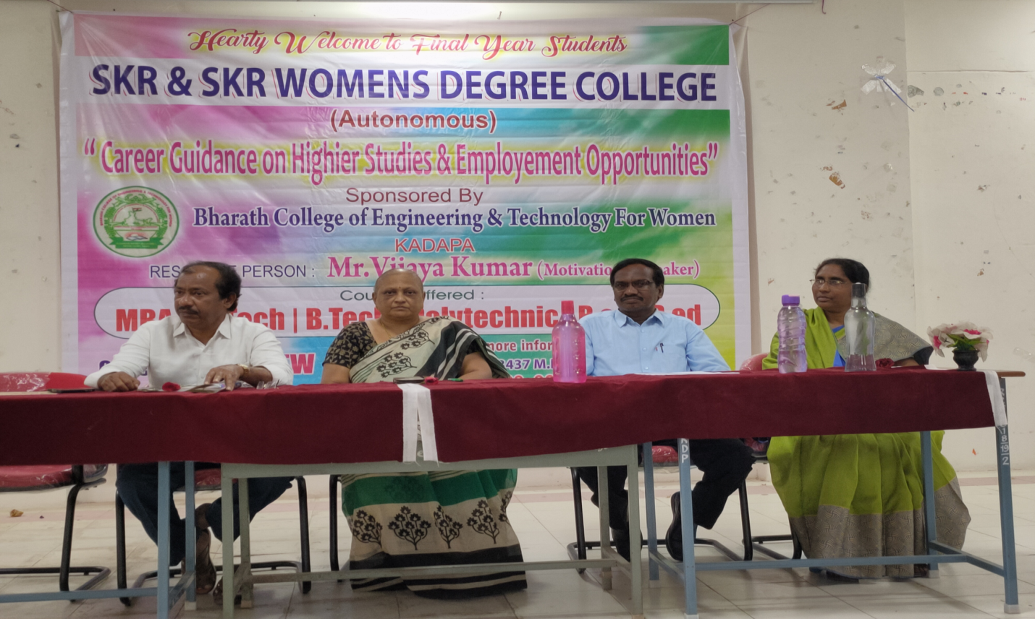

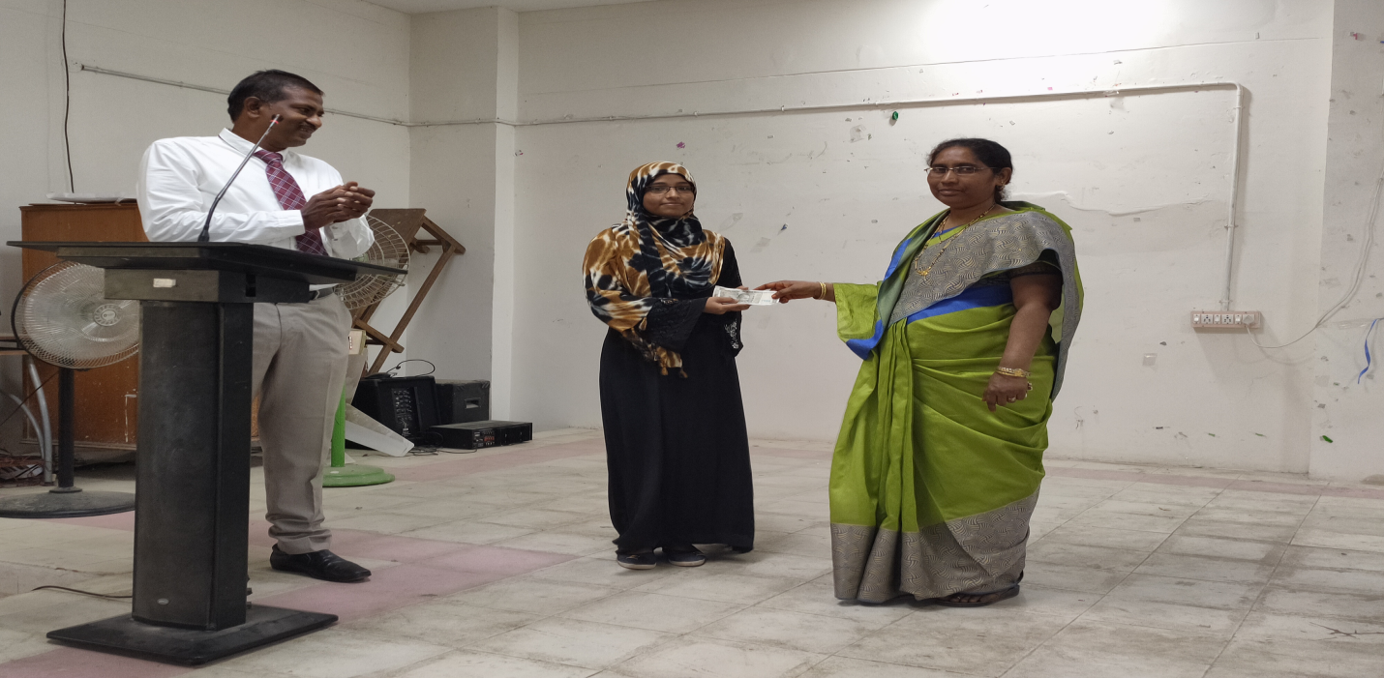
I Prize (Cash Prize Rs.1000) winner Kum. S.Noorjahan, III B.Sc (M.S.Cs)

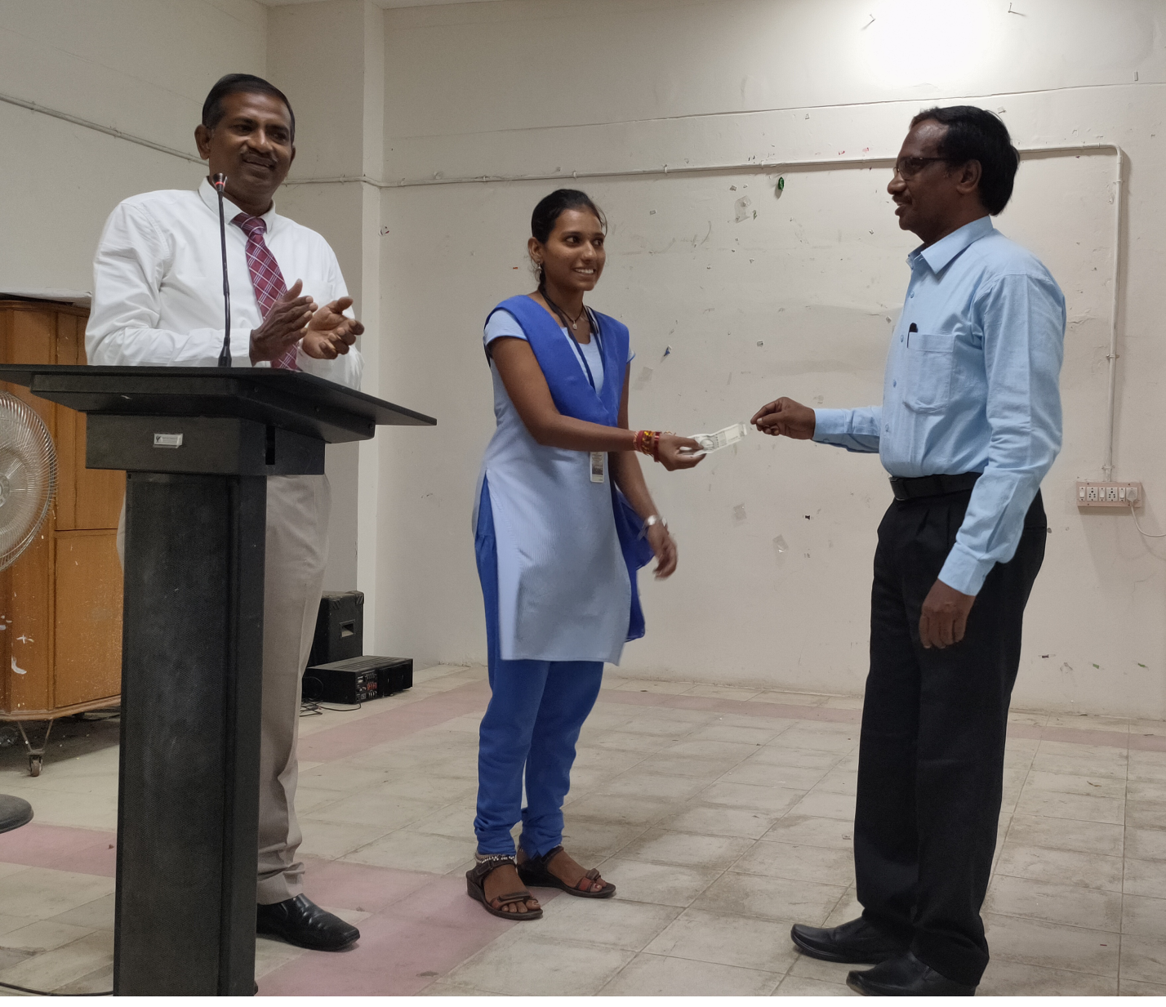
II Prize (Cash Prize Rs.500 ) winnerKum. V.Vasavi, II B.Com, C.A.
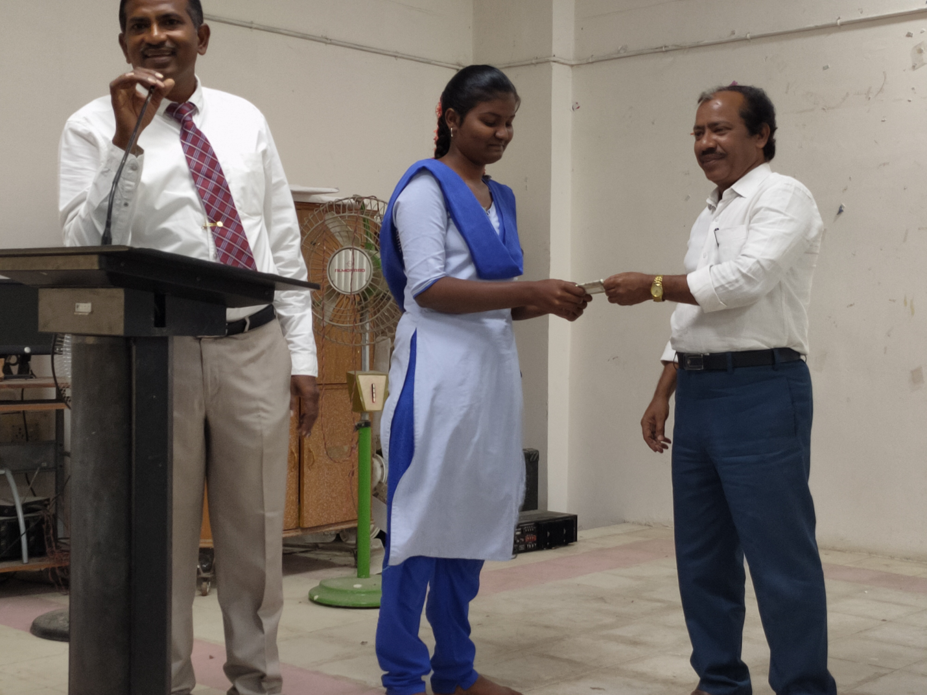
III Prize (Cash Prize Rs.500 ) winnerKum. M.Mounika, IInd B.Com., C.A.

CAREER GUIDANCE AND PLACEMENT CELL
Employment On Career Counselling
Dt: 22-02-2019

The College Career Guidance Cell organized a programme on 22-02-2019 entitled “ EmploymentOn Career Counselling” with Resource Person Sri. M.C. Raveendra, Director of SPIRTS College explained about the contribution in education on skills for getting better opportunities in this global world.Dr. K. Nagamuni Reddy, Coordinator of this programme said that programme will help the students to decide their career for better future.

Coordinator
Dr.K.Nagamuni Reddy
Dept. Of Chemistry

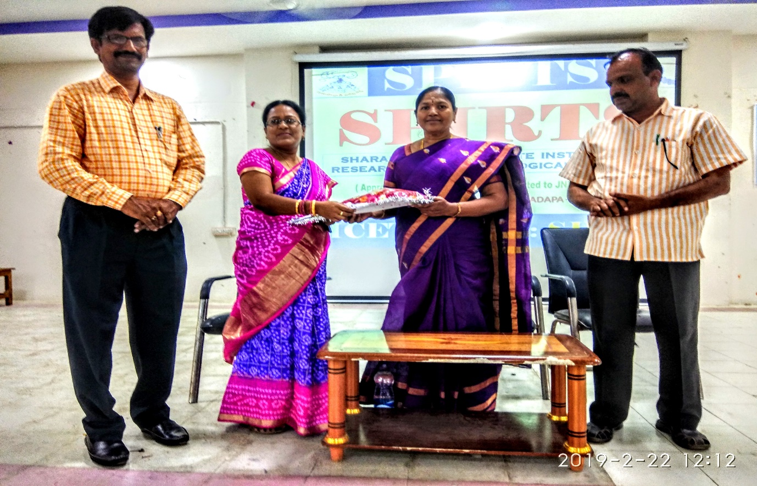

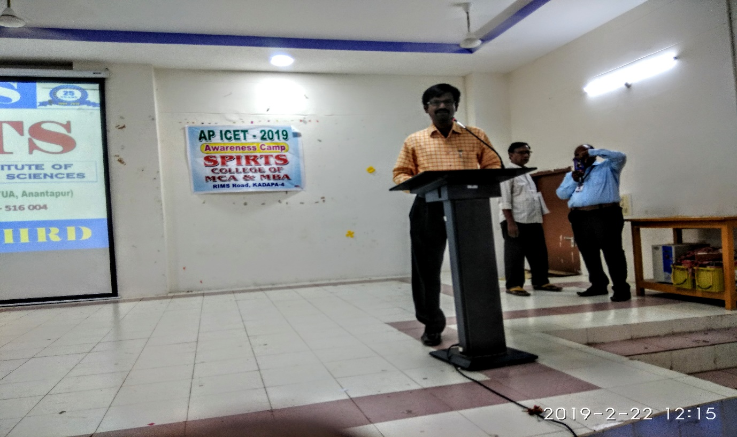
Sri. M. Ravi Shankar Garu, Principal, SPIRITS College of MCA and MBA is explain the Career and Job Opportunities for the Final Year Students.

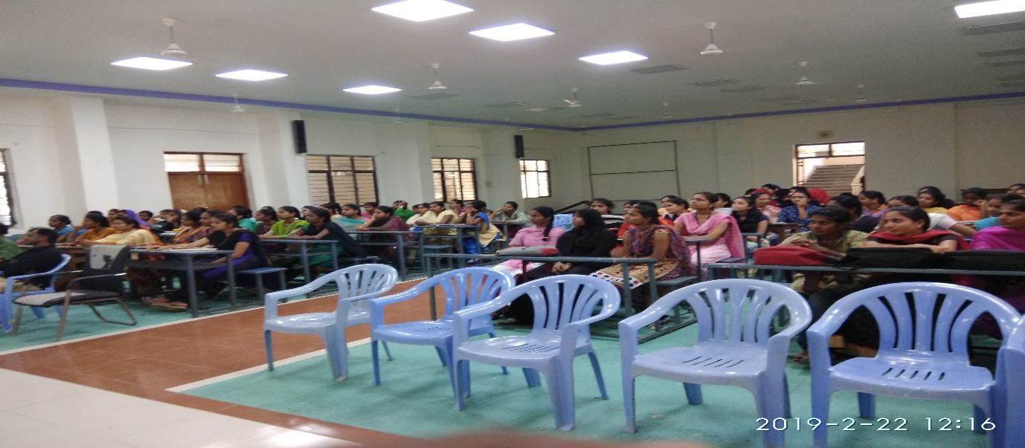
Students participation in Employment Skills

CAREER GUIDANCE AND PLACEMENT CELL
Employment On Career Counselling
Dt: 16-02-2018

The College Career Guidance Cell organized a programme on 16-02-2018 entitled “ Employment On Career Counselling” with Resource Persons ofSai Balaji Coaching Centreexplained about the contribution in education on skills for getting better opportunities in this global world.Dr. K. Nagamuni Reddy, Coordinator of this programme said that programme will help the students to decide their career for better future.

Coordinator
Dr.K.Nagamuni Reddy
Dept. Of Chemistry

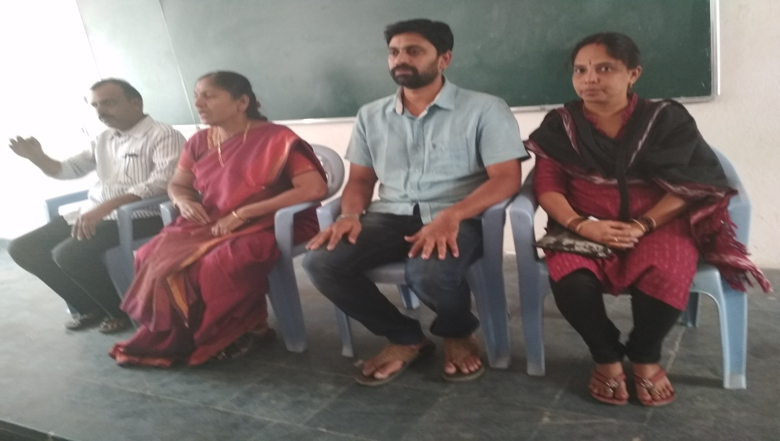
Sai Balaji Coaching Centre on Employment Opportunities

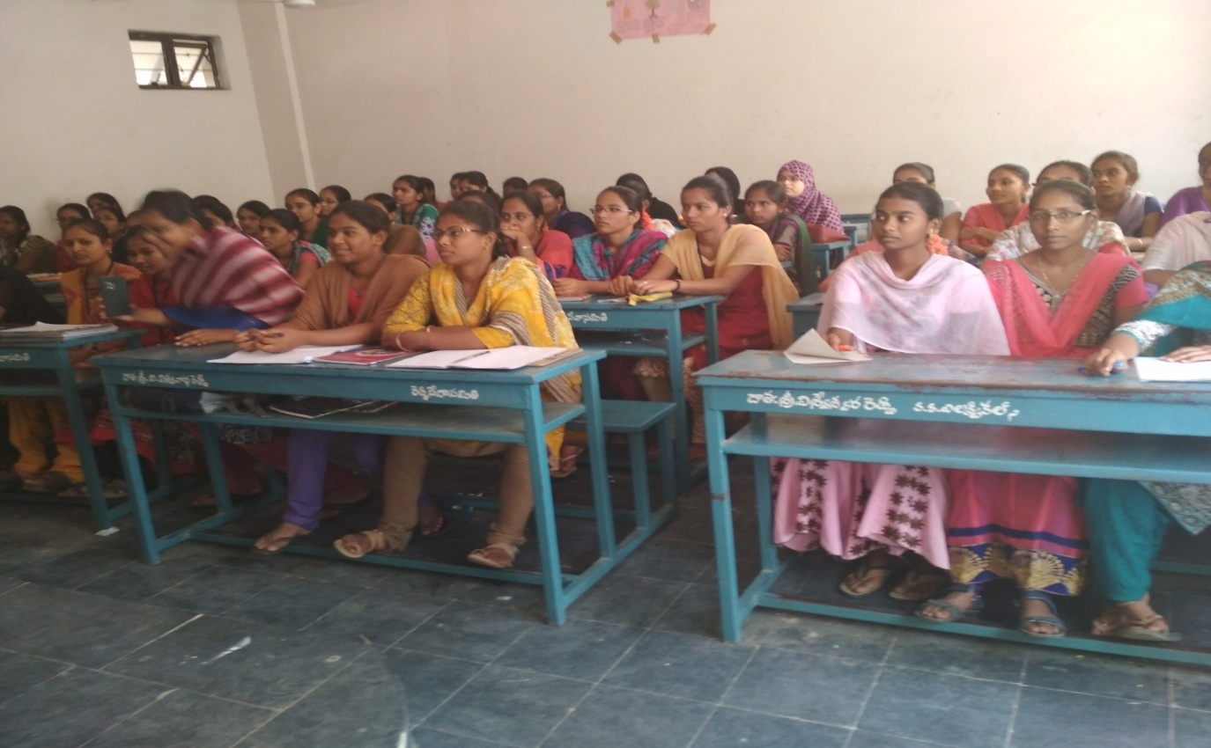
Final Year Students of SKR & SKR Govt. College (A), Kadapa are listening about the Employability Skills on Group 2 online coaching

CAREER GUIDANCE AND PLACEMENT CELL
Employment Opportunities in Various Public and Private Sectors
Dt: 30-01-2018

The College Career Guidance Cell organized a programme on 30-01-2018 entitled “Employment Opportunities in Various Public and Private Sectors”with Resource Persons ofSri Venkata Sai Coaching Centreexplained about the contribution in education on skills for getting better opportunities in this global world.Dr.P.SubbaLakshumma, Principal and Dr. K. Nagamuni Reddy, Coordinator of this programme said that programme will help the students to decide their career for better future.

Coordinator
Dr.K.Nagamuni Reddy
Dept. Of Chemistry

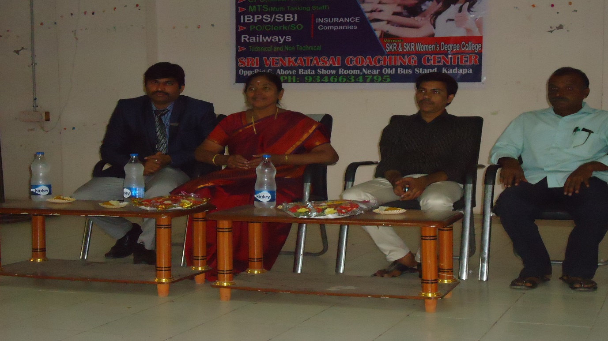
Representatives of Sri Venkata Sai Coaching Centre explained on employment opportunities in various public and private sectors
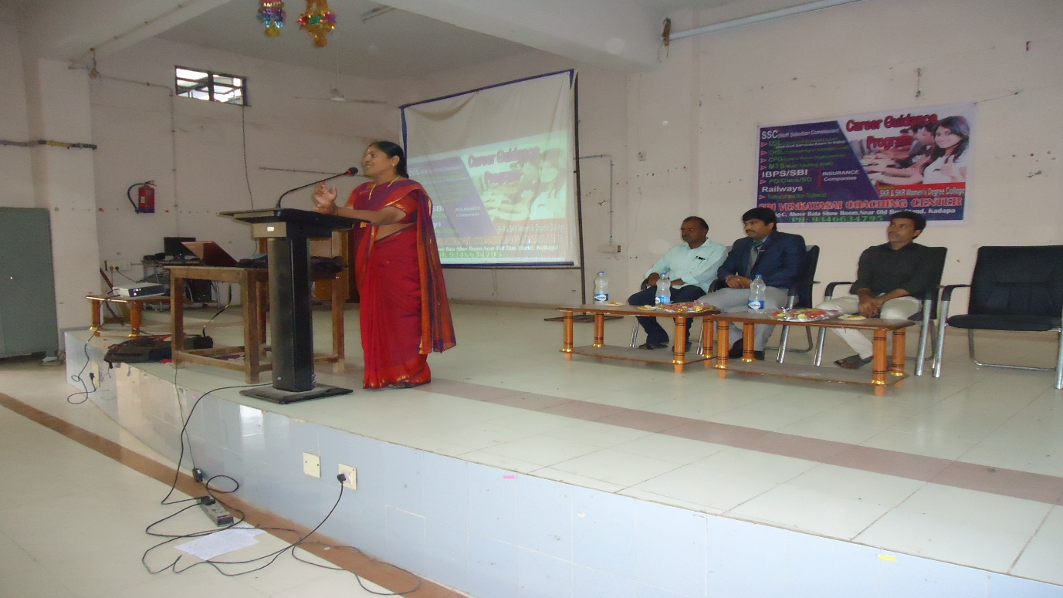
Dr.P.SubbaLakshumma, Principalis addressing the third year students on employment opportunities in various public and private sectors.

CAREER GUIDANCE AND PLACEMENT CELL
Employment Opportunities and Related Skills
Dt: 12-01-2018

The College Career Guidance Cell organized a programme on 12-01-2018 entitled “Employment Opportunities and Related Skills ”with Resource Persons Sri B.Janardhana Reddy, Founder and Smt.B.Swathi, Chairman of Toppers Academy, Kadapaexplained about the contribution in education on skills for getting better opportunities.Dr.P.SubbaLakshumma, Principal and Dr. K. Nagamuni Reddy, Coordinator of this programme said that programme will help the students to decide their career for better future.

Coordinator
Dr.K.Nagamuni Reddy
Dept. Of Chemistry

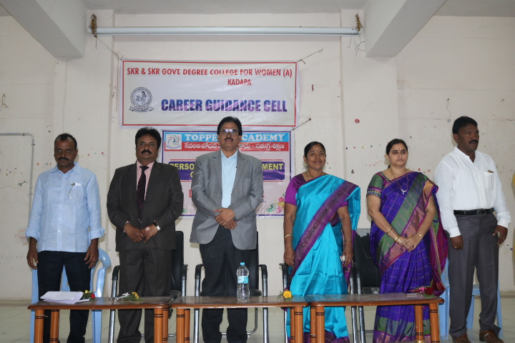
Dr.P.SubbaLakshumma, Principal and Dr.K.Nagamuni Reddy, Coordinator Career Guidance Cell and Representatives of Toppers Academy, Kadapa.
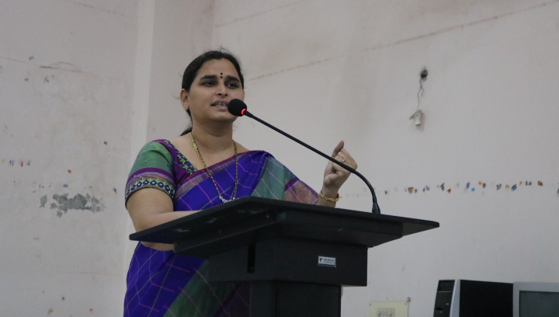
Mrs. B. Saraswathi, Chairman of Toppers Academy, Kadapa addressing the students about the employment opportunities and Related Skills

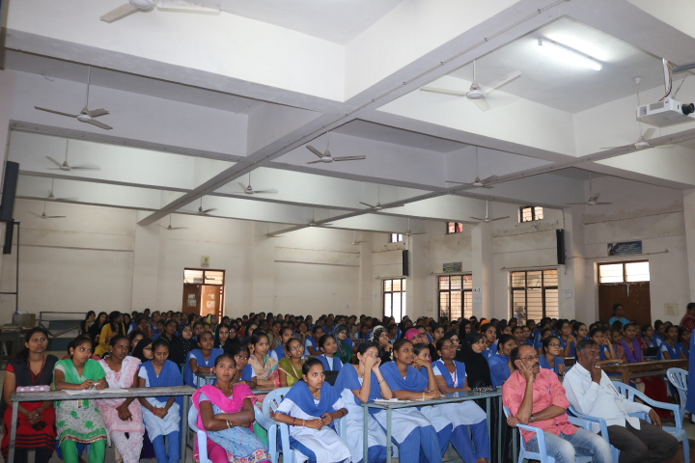
Final Year Students are listening about the Employability Skills on StaffSelection Commission) and Group 2 coaching presented by Mrs. B. Saraswathi, Chairman.

